**Helpful Instructions for VS Code**

**Cloning a Git Repository:**

1. Click on Source Control on the left side of VS Code
2. 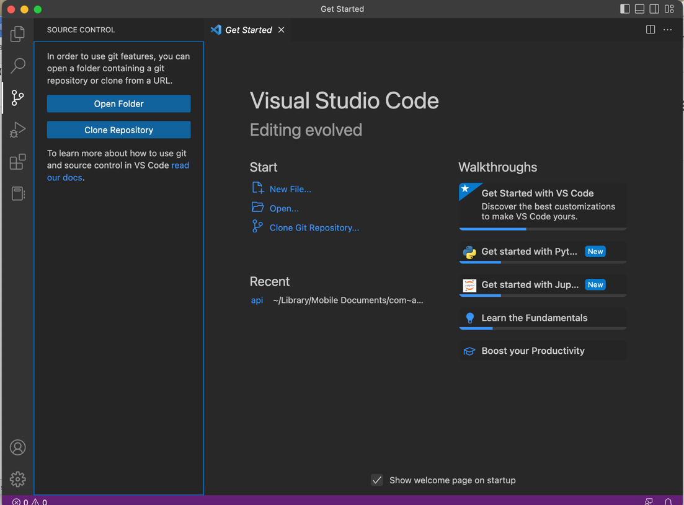Click Clone Repository
3. Enter the github URL given to clone the repository –

<https://github.com/johnnybhojwani/IntrotoVS.git>

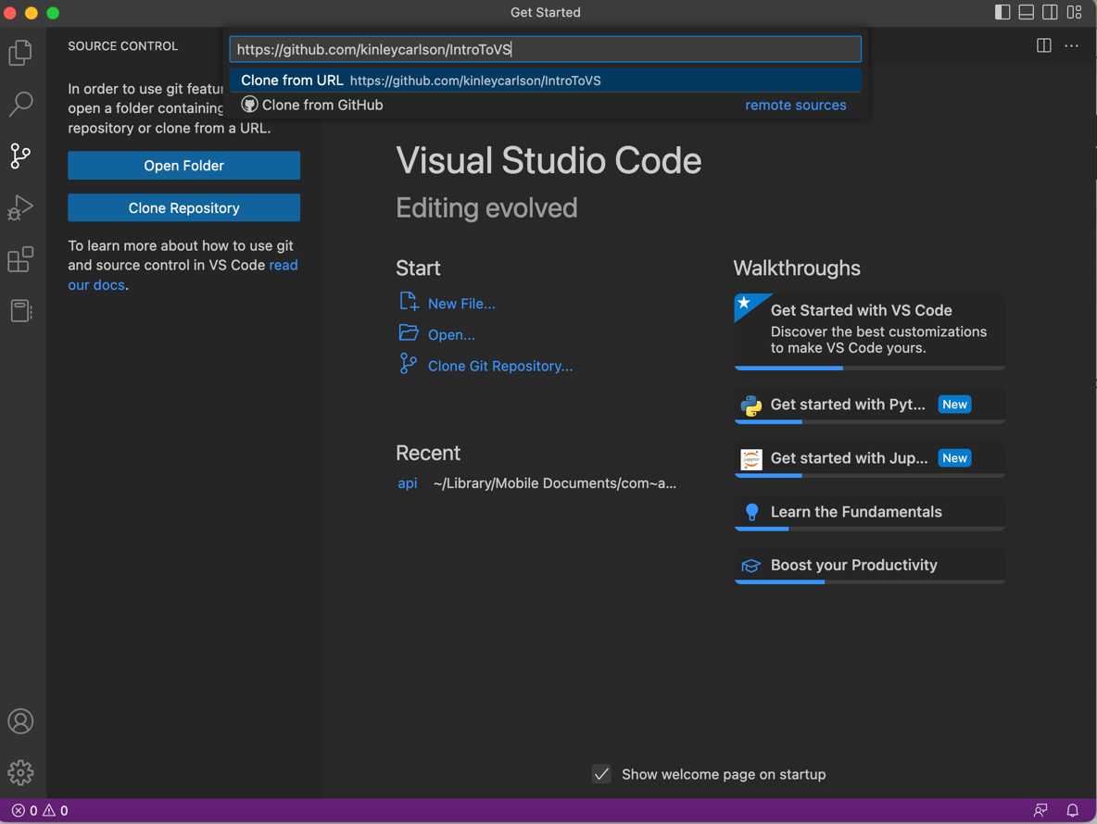

1. Select the location to save the repository. You should put it in your AdvPython folder, but do not double click the folder to open it when saving as the repository destination. Just select the folder itself shown in the picture below.

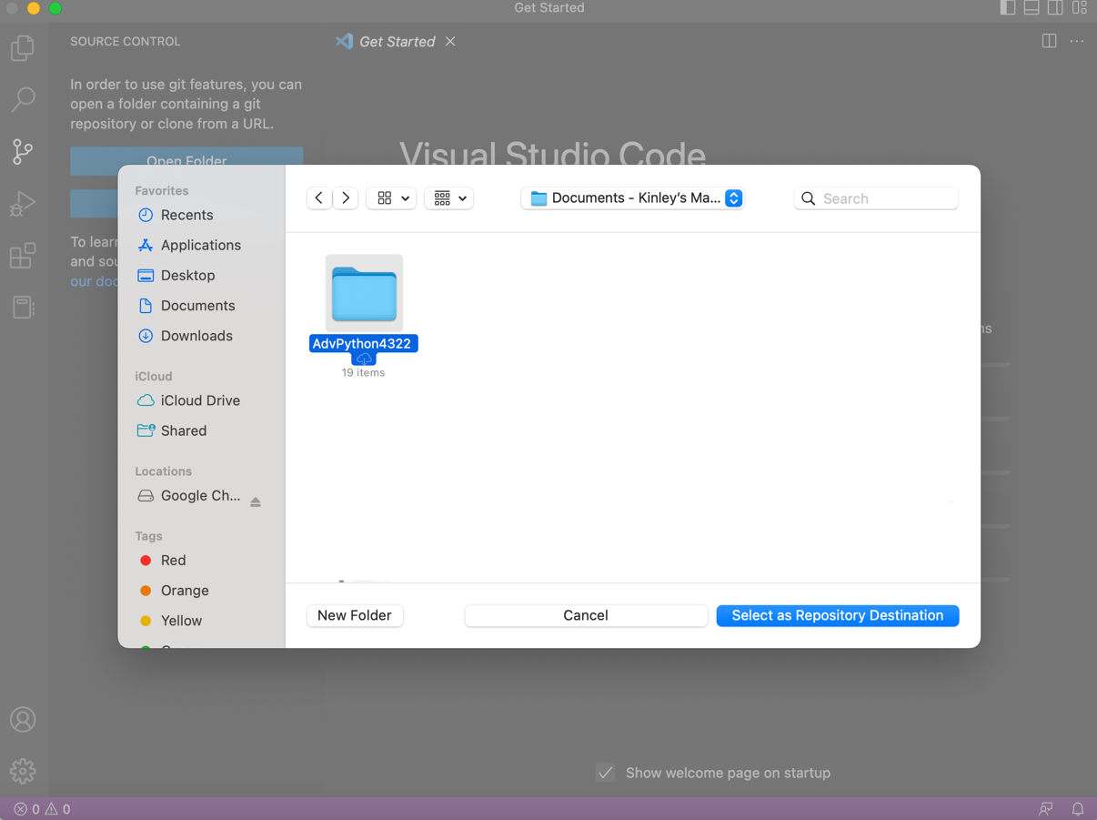

**Setting Up and Activating a Virtual Environment:**

1. Open a new python terminal… go to terminal in the menu bar

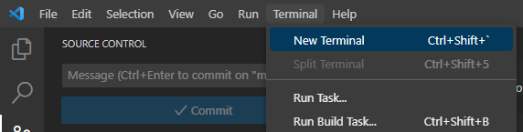

1. **Create a Virtual Environment**

Mac Users: **python3 -m venv .venv**

Windows Users: **py -3 -m venv . venv**

**NOTE:** “**.venv**” is the name of your virtual environment and can be named anything you would like

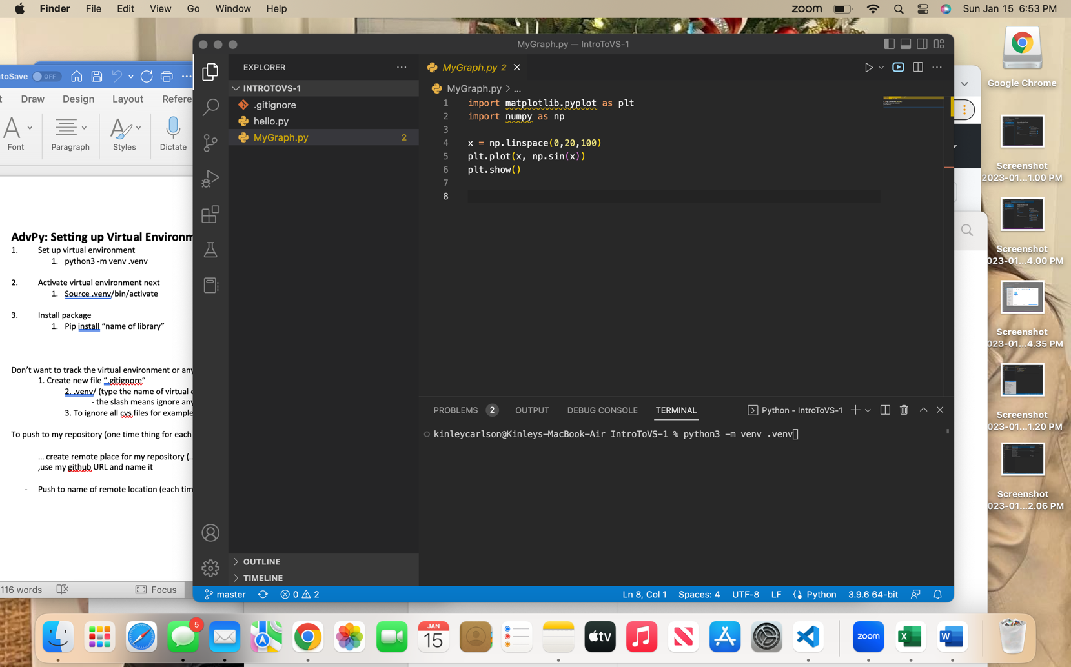

1. **Activate the virtual environment**

MACs: **source .venv/bin/activate**

Windows: **.venv/Scripts/activate**

**NOTE:** “.venv” is the name of your virtual environment, so if you have a different name, this code will change based on what you called it

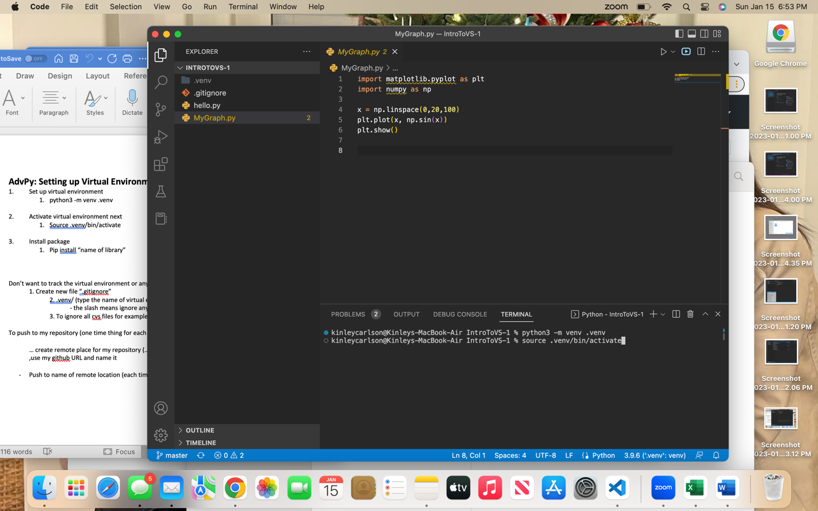

**Installing libraries:**

1. Before installing external libraries, make sure you have activated your VE (Virtual Environment). You will know if it is activated since it will show in the terminal at the beginning of the prompt.

**NOTE**: **Macs** show the VE in back and white but in **Windows** it is green.

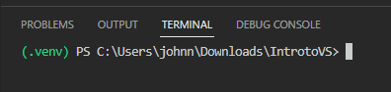

1. Once activated, install the library needed

**pip install [name of library]**

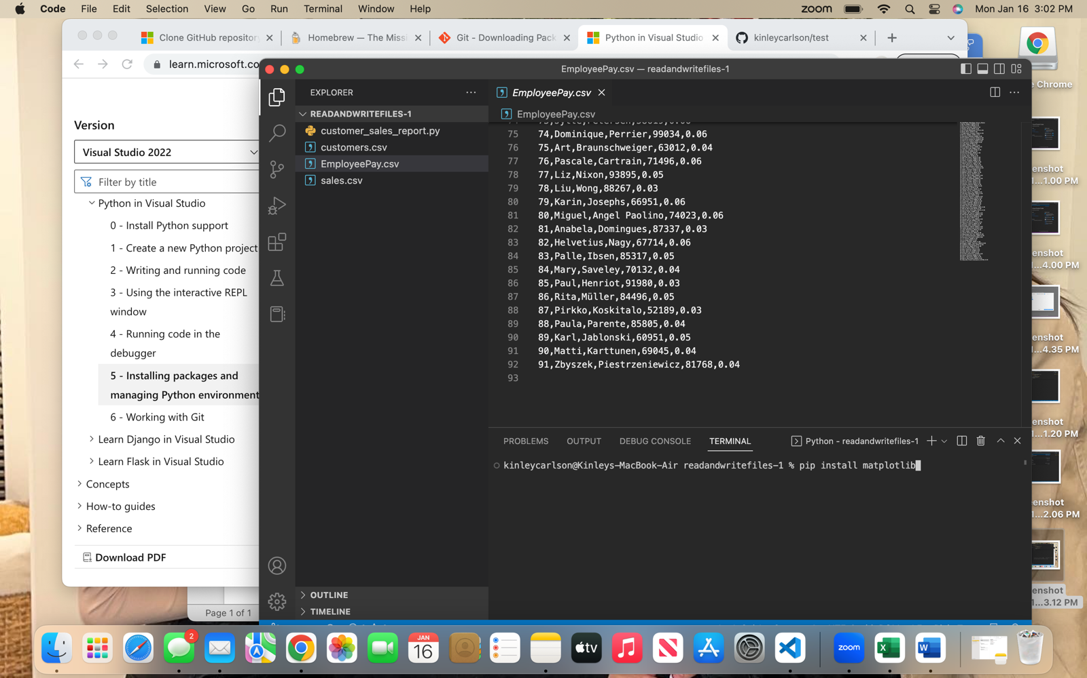**NOTE:** [name of library] is the external library needed for the program to run. In the below screenshot the library that is being installed is **matplotlib**

**Pushing your Files to a Git Repository:**

1. Go to your git hub account and create a new repository. Enter in the name of the topic that you are working on and then copy the URL given.

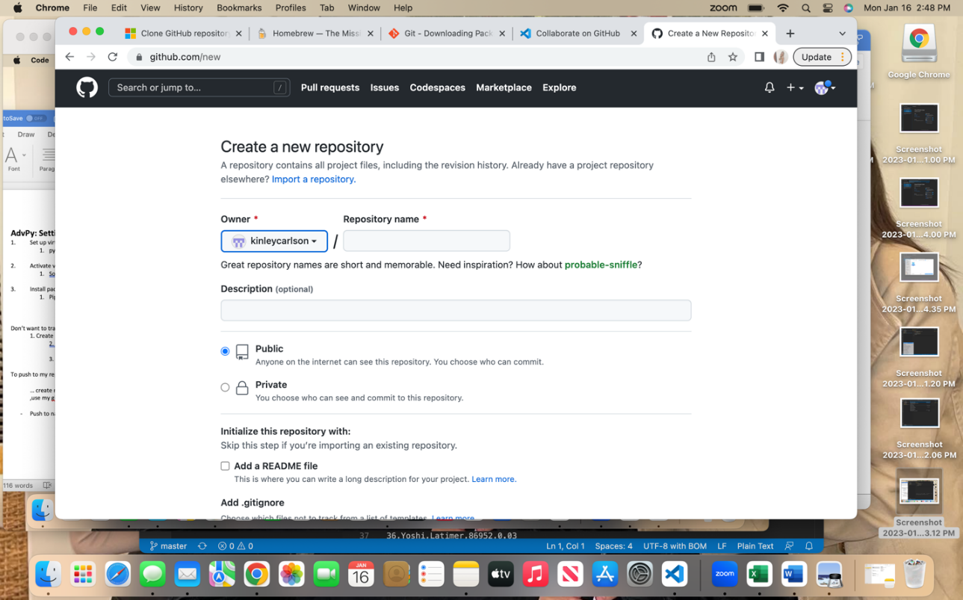

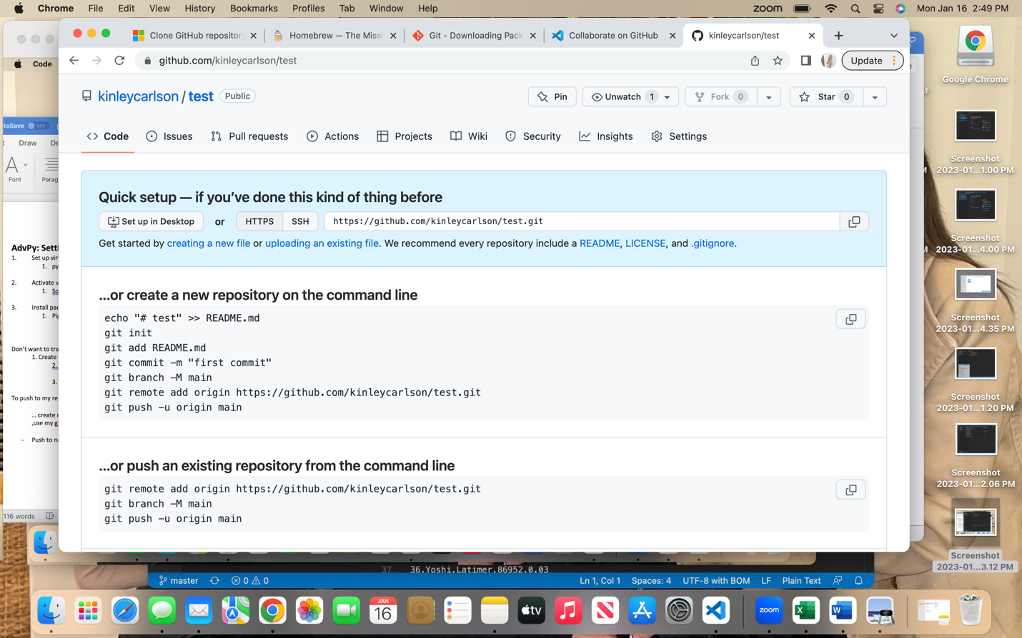

1. In VS code, go to **source control** and click on the ellipsis.

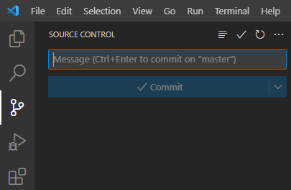

1. Then go to remote > add remote

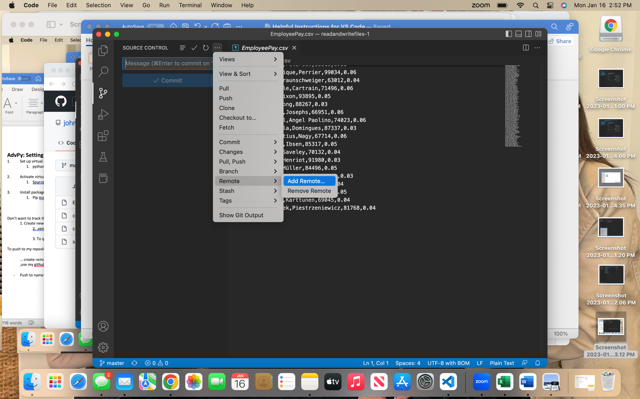

1. Paste the URL from github and press enter.

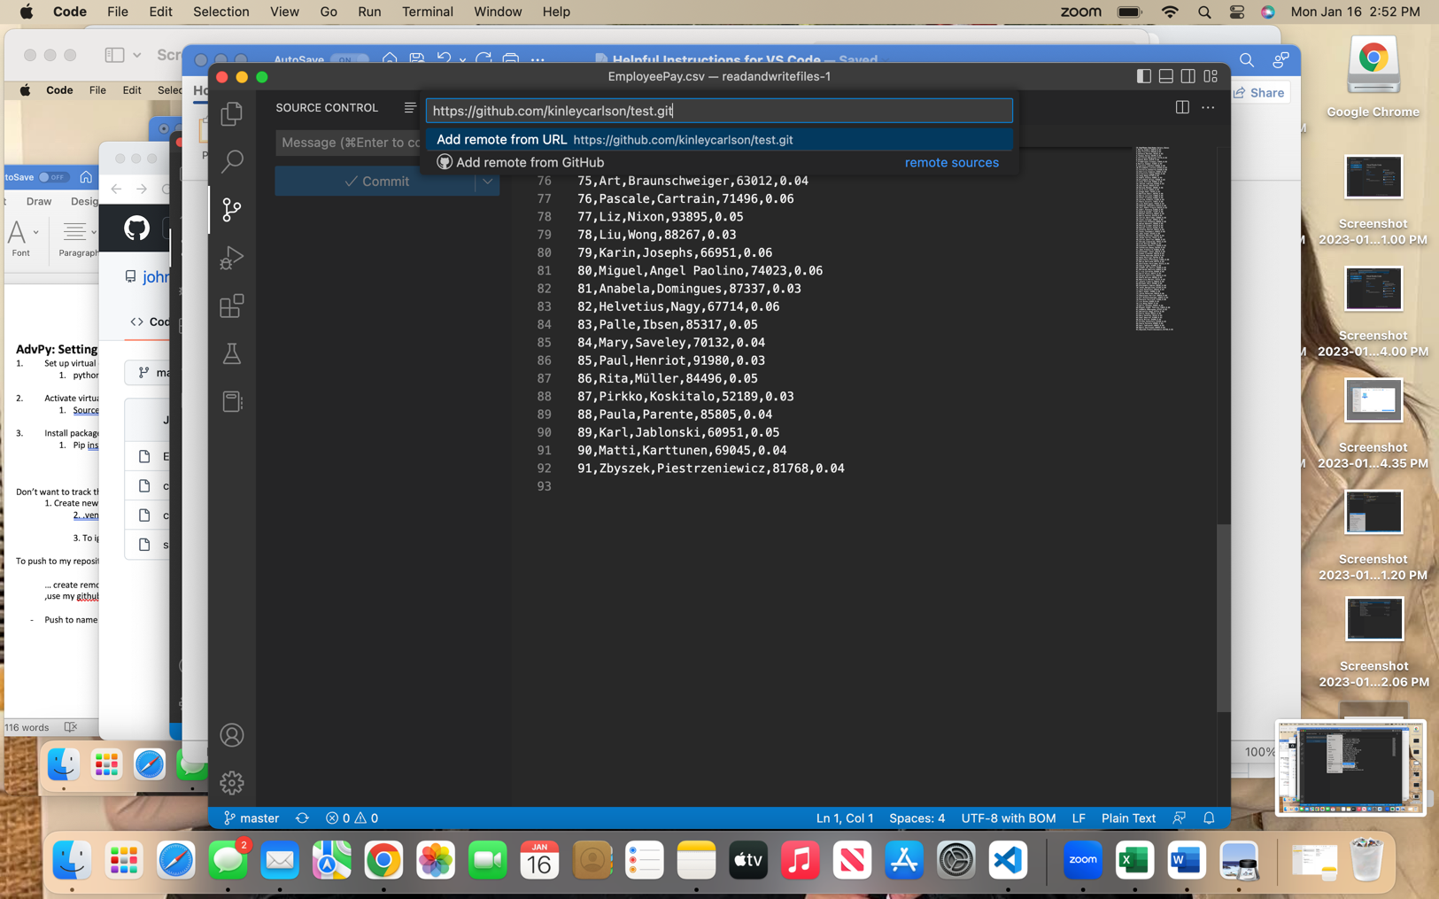

1. Give your remote location a name. In this case, the name is **R1**

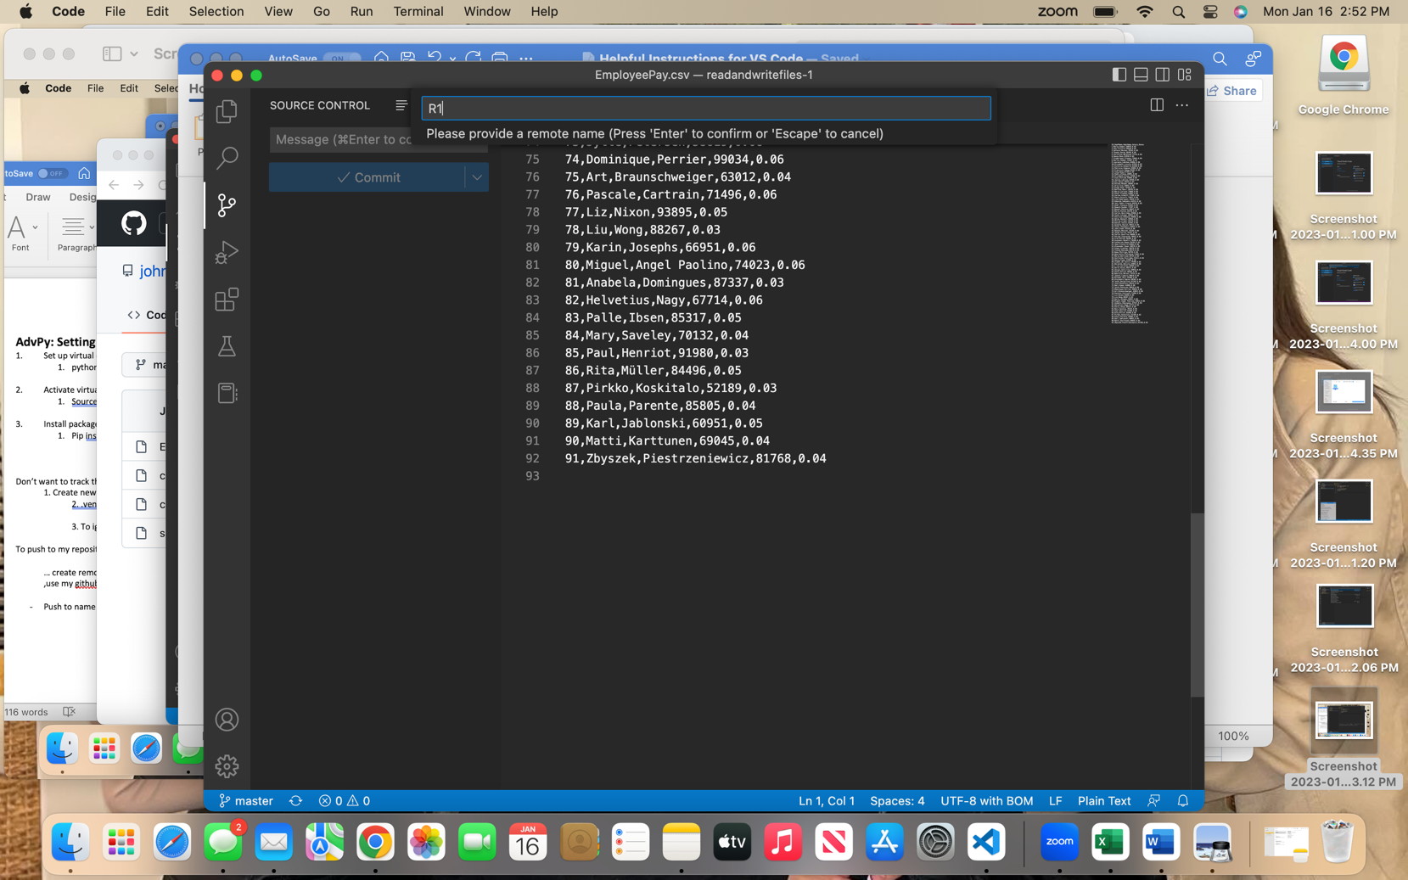

1. You then need to push all your files to your remote location. You will need to do this each time you make changes to your files. Go to the ellipsis in source control > push> push to, and then select the name of your remote location.

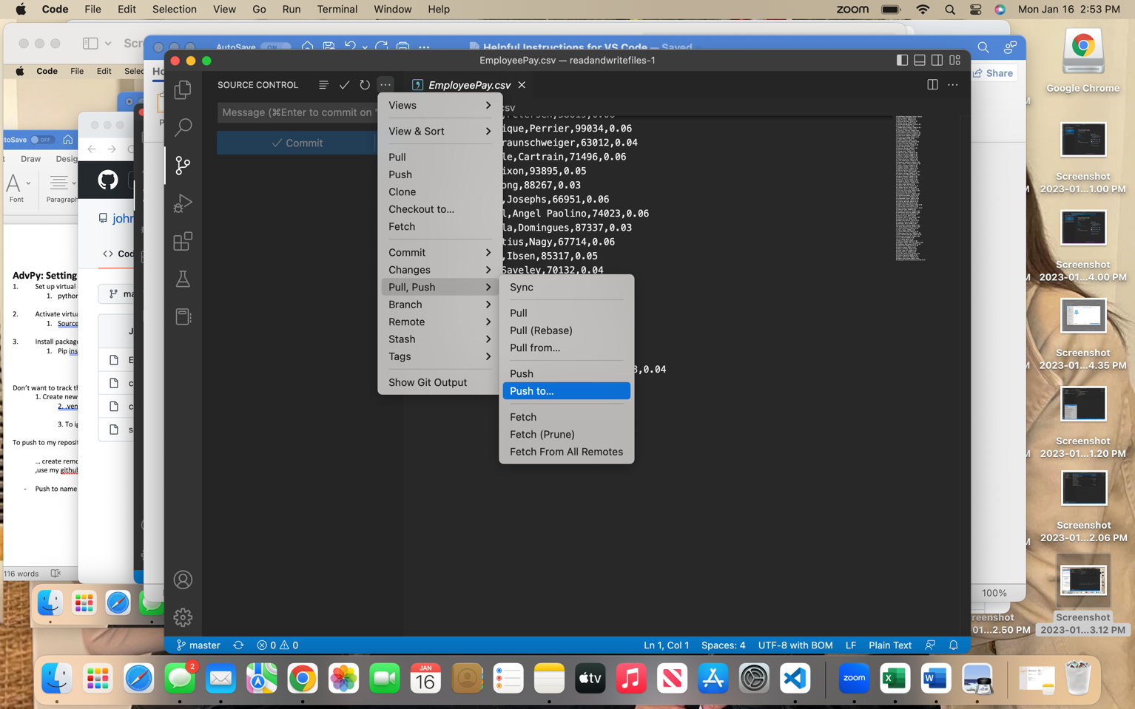

1. Create a VE (python3 -m venv myvenv)
2. Activate the VE (source myvenv/bin/activate)
3. Install 3rd party library (pip3 install matplotlib) – matplotlib is a library and varies

Exam Pts:

1. Left (original/currently in repository)

1+ Right (the changes)